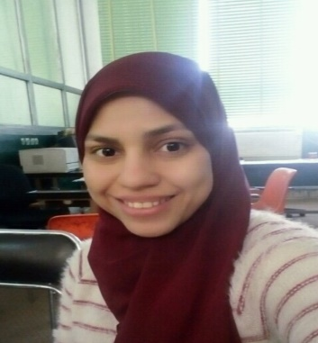**Curriculum Vitae**

**Safaa Abd El_Aziz Abd El_Zaher**

Department of Mathematics, Faculty of Science, Assiut University Assiut, Egypt

**Contact Information**

Email Address: [safaaabdelaziz@science.aun.edu.eg](mailto:safaaabdelaziz@science.aun.edu.eg)

[Safaaabdelaziz928@gmail.com](mailto:Safaaabdelaziz928@gmail.com)

Mobile Phone: +201157202866

Address: Alghaanayem- Asyut- Egypt

Country: Egypt.

**Personal Information**

Full Name: Safaa Abd El_Aziz Abd El_Zaher Soliman

Date of Birth: 18/1/1995

Gender: female

Marital Status: Married

Nationality: Egyptian

Religion: Muslim

**Education and qualifications**

University: Assiut University

College: Faculty of science

Department: Mathematics

Grade: Very Good (B+) with GPA (3.61/4)

Ranking: The 1st over the Department

Period: 10/2014 : 6/2018.

**Work Experience**

Demonstrator at Faculty of Science "Mathematics Department" in Assiut University (9/2019: till now).

**Computer Skills and Software**

Good command of Microsoft window tools (word, excel, power point, access).

International Computer Driving License (IC3).

Languages: Matlab, Spss, Mathematica.

**Language Skills**

Arabic: Native Language.

English: good.